
DA Software Solutions (Pvt.) Limited.
#76, Pagoda Road, Nugegoda. Sri Lanka.
E-mail: dumindu@dassonline.com
Phone: +94 114 941 921, +94 773 435 429

Client Name/Address
Date : 18th July 2011
Our Reference : DASS /INV
Invoice Number : TI 263

MBSL Savings Bank
#2, Deal Place,
Colombo 3.

INVOICE
Description
“Pawn - Brokering Management” Software Solution

Particulars | Amount (LKR)
Invoice Balance implementation cost | 75,000.00

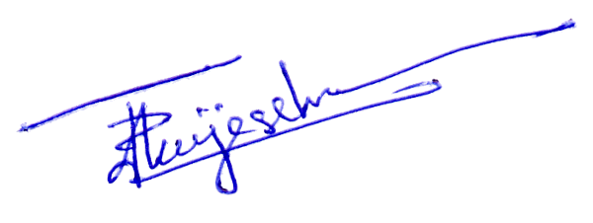
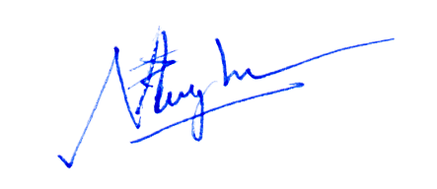

Prepared by: ………………………………. Authorized by: ……………………..................

